**A New Way to Visit our Historical Village**

*(The first six pages of this document describe the initial 2016 implementation, and have been left intact, for reference purposes. Subsequent changes are documented at the end of the file.)*

There are two events that occurred in the summer of 2015 which prompted me to consider alternatives to the current docent-led visit strategy at the New London Historical Society’s campus.

That spring, I discovered that the WFK Icehouse Museum was providing a tablet computer for visitors to use in order to access selected video clips related to the museum and they had posted QR codes on the related identification stands which allowed the user to immediately access these YouTube videos by scanning the QR code with the camera built into the tablet. While I thought this was a great concept, I also thought that there were opportunities to improve this implementation.

 

The second event was the broadcast of four episodes of WMUR’s New Hampshire Chronicle which were hosted at our Historical Village, and the resulting increase in visitation on Sundays. While the greatest complaint from our docent staff in prior years was that “We were open for three hours and nobody visited us”, the issue for 2015 was “We had so many visitors that we couldn’t provide everyone with a personalized tour”.

As a result, I propose that we offer an alternative to the docent-led tour in 2016 – the self-directed, web-assisted tour. This new approach is not intended to replace the docent-led tour in all cases, nor does it substantially change the need to staff each of our buildings during certain special events. However, it does provide an alternative which can supplement the traditional approach in some cases, replace it in others, and open up additional opportunities to visit our historical village.

There are two major components to this new approach. First, we need to provide wireless (Wi-Fi) access throughout the village and provide a number of wireless devices which can be used by our visitors. Second, we need to develop the content (text, video, etc.) which will form the “meat” of the self-directed, web-assisted tour. I have put together a “proof of concept” implementation which provides a starting point for this effort.

Wi-Fi access is a particular problem because of the acreage that our village covers. Furthermore, our only internet access is located in the NLHS office at 73 County Road, well removed from the rest of the village. Adding to this, there are potential security issues associated with sharing our existing administrative internet access with our visitors. If Wi-Fi access is limited to NLHS-provided tablets, this can be managed by limiting the number and types of “apps” that are installed on the tablets. However, this also limits its use to the hours when the village is open and further limits it to the number of NLHS-provided tablets.

An alternative is to implement a self-contained wireless intranet within the village and to “host” the content on a server that is connected to this intranet. We have a couple Windows XP computers which have limited usefulness as administrative workstations but could be put to alternate use such as this. As luck would have it, we also have an unused wireless router which could form the backbone of this village-only intranet.

Whether we opt to extend the wireless signal from 73 into the village or implement a self-contained wireless intranet, the scale of the village campus presents some potential problems. As a starting point, I have installed a Wi-Fi range extender in the Transportation Building. This device picks up the Wi-Fi signal from 73 and re-broadcasts it, extending the range of the existing internet connection. However, even this only expands the Wi-Fi coverage area to a part of the village – TB, Phillips Barn, and, depending on wireless device, the Meeting House.

If we are to provide Wi-Fi access throughout the village, we need to start with a backbone that is primarily hard-wired, not wireless. However, the cost of installing cat5 cable throughout the village would be substantial. Fortunately, there appears to be an alternate technology which would provide many of the advantages of a dedicated hard-wired Ethernet service without the inherent cost.

Currently, the electrical service for the village is split across three meters – one for the Transportation Building (although the meter is actually mounted on the Meeting House), one for the Meeting House, Phillips Barn, and Lauridsen Building, and one that fans out from the Griffin Barn to serve the Scytheville House and the remaining buildings. (There seem to be two sets of electrical service for the Lauridsen Building, with the second service appearing to connect to the Schoolhouse. It is possible that some portion of the electrical service is on the second circuit, although I have not been able to identify what is served by that service.)

It is my proposal that we use this shared electrical service to propagate the intranet signal throughout the village. As a test, I have acquired a pair of powerline adapters which insert an Ethernet signal into the electrical wiring, then allow that signal to be accessed from any other location serviced by that electrical meter. The second adapter has a built-in Wi-Fi access point, broadcasting the same signal as the original wireless router. I have also ordered a wireless bridge, which picks up an existing Wi-Fi signal and connects to a wired Ethernet environment. It is my expectation that we would be able to capture the signal from the Wi-Fi range extender in the TB by placing the Wi-Fi bridge and a powerline adapter in the Meeting House (or Phillips Barn) and feed the signal to a powerline adapter / Wi-Fi access point in the Lauridsen Building. If this is successful, we can either run a short length of exterior cat5 cable between the Lauridsen Building and the Schoolhouse or install another Wi-Fi bridge in the Schoolhouse to pick up the signal and introduce it into the electrical wiring serving all the buildings between the Scytheville House and Eagle Hose Company, via a powerline adapter. (In fact, if both the Meeting House and Griffin Barn electrical services are present in the Lauridsen Building, it might be possible to bridge the two powerline Ethernet services directly.) Once the signal is present in the electrical service, we can install powerline adapter / Wi-Fi access points in as many buildings as necessary to provide seamless Wi-Fi coverage throughout the village.

In parallel with the effort to bring internet access from 73 County Road, I have also been investigating what it would take to set up a free-standing intranet environment. Using an available Windows XP computer and the surplus wireless router, I have created a small intranet server to host our web content.

With that established, we then have the option of implementing either the internet or intranet approach. There is even a hybrid approach that provides some of the advantages of each approach. If we go the internet route, we create an infrastructure that we can use for whatever administrative networking needs we might have within the village, down the road, although the throughput of the powerline adapters could prove to be a limiting factor. However, the internet approach also means that we either limit access to NLHS-owned devices or we start providing the SSID and network password to any visitors who would prefer to use their own wireless devices. On the flip side, the intranet approach has little if any network security risk and the bandwidth constraints should not impact the limited network traffic volume of the web-assisted tours. For this reason, I have disabled the password on the prototype intranet. Users can connect to “NLHS_Net” without needing a password, since the only data they can access is the content that we have provided on the intranet server.

A hybrid approach could provide administrative Wi-Fi internet access to the Transportation Building and immediate vicinity (Phillips Barn and Meeting House), but not use this network for the web-assisted tours. This would allow the bartender at Reflections to process credit card transactions via Wi-Fi, but wouldn’t open up Wi-Fi internet access to the typical visitor. In this scenario, the web-assisted tours would be hosted on a separate intranet network, which would have Wi-Fi coverage that overlapped the internet Wi-Fi network. (Just as Wi-Fi internet coverage for the Phillips Barn and Meeting House would be provided by the Wi-Fi range extender in the Transportation Building, Wi-Fi intranet coverage for the Transportation Building would be provided by a Wi-Fi access point in either the Phillips Barn or Meeting House.)

Concurrent with this infrastructure work, I have also been working on a prototype of what the content might look like. I started with a web page that displays a map of the village and then defined “hot spots” on the map which are connected to other web content (see below).

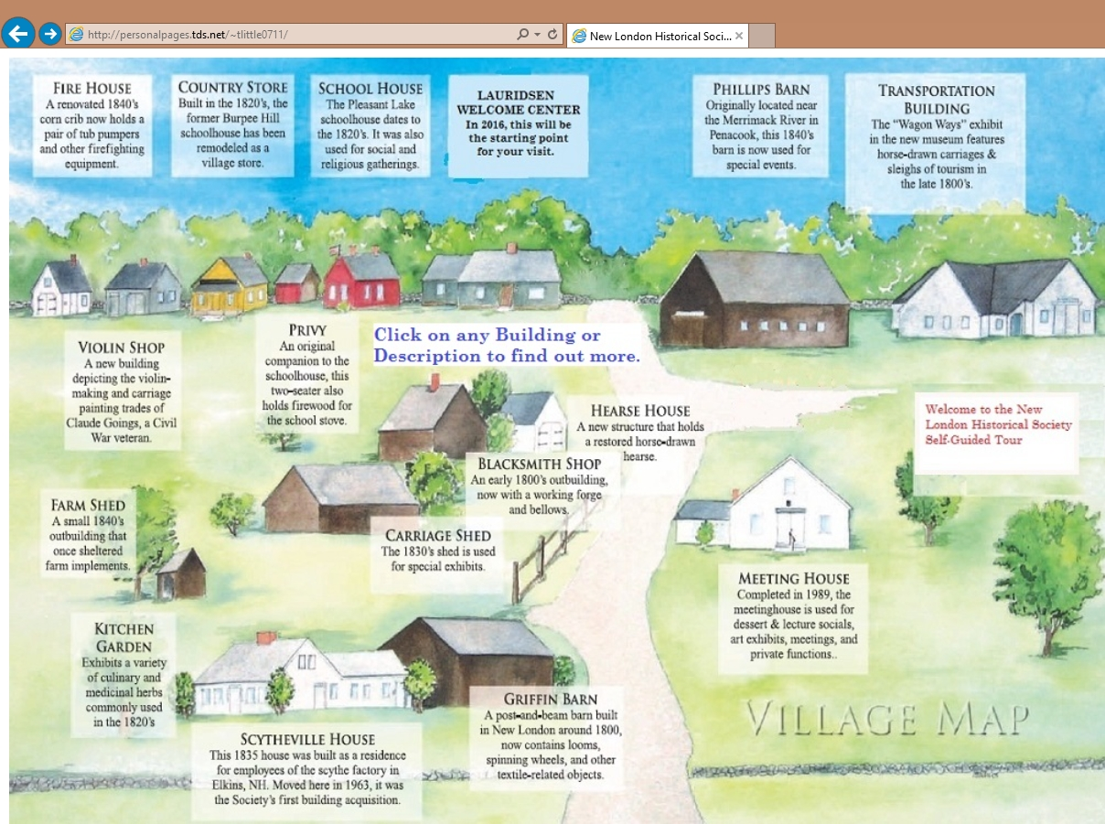

When you click on a hot spot, the link takes you to one of several identically formatted pages, as shown in the next screen shot. The largest element on the prototype web page is a photograph of the building, although this image could be scaled to provide more space for text. To the left of the photograph are two groups of information. The green text represents links to additional information which, for demonstration purposes, are links to videos which have been stored as part of the website. (Some of these videos are also available on YouTube, but I opted to store them as part of the website since that would be a requirement if we went the intranet route.) Below the links is a block of text that I anticipate being used to describe the building. Finally, I’ve added a set of standard links (“Home” which I may rename as “Map”, “About Us”, “Join / Contribute”, and “Contact Us”) that will be right-justified at the top of the page. (If we opt for the intranet approach, the PayPal-based “Join / Contribute” link would have to be eliminated. The “Contact Us” link might also have to be eliminated although there is a possibility that we could still accept pseudo-email messages on the intranet web server.)

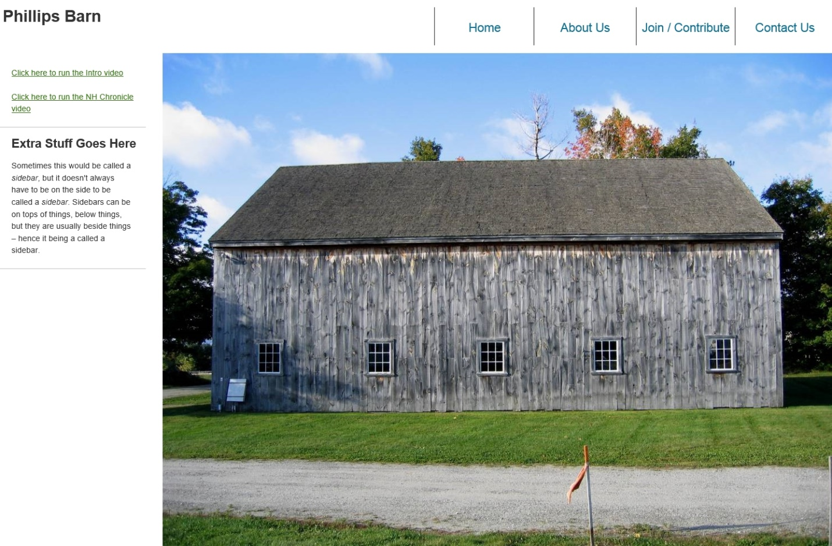

The standardized layout has been defined in a Cascading Style Sheets file which is separate from the HTML for the pages themselves, so it would be possible to tweak or totally revamp the standard layout by changing one file.

This web environment has been uploaded to my personalpages.TDS.net account, where it is available for internet-based testing from anywhere. (This web content could be uploaded to the NLHS website prior to “going live”, although not necessarily linked to the publicly accessible web content.) I also loaded an identical set of files on the Windows XP computer that has been set up as our prototype intranet server and, at least temporarily, placed in the Lauridsen Building. Consequently, we now have limited prototypes of both the internet and intranet implementations available for review.

I mentioned the QR codes at the beginning of this write-up but really haven’t expanded on their use. We could, potentially, print and post a QR code for any webpage that we have. This is true whether we use the internet or intranet model. As a minimum, we should have a QR code that takes you to the Map page, displayed at the location in the village where we expect folks to start their tour. This is particularly true in the intranet configuration, since the URLs will look a little strange (server IP address instead of host name) so they might be awkward to type into a web browser. How prolific we are is our choice. If we think that people will start from the map and migrate through the various pages, then all we need is a QR code to get them started. On the other hand, if we think that folks will wander around and only look for supplemental information for specific items, then we need a QR code for each of the likely queries.

(As part of the test implementation, the QR code on the left side of the first page of this document will link you to the internet version of the prototype website while the QR code on the right side should link you to the intranet version. The intranet version is only accessible if you are in the vicinity of the Lauridsen Building or Meeting House and have connected to the unsecured NLHS_Net Wi-Fi network.)

What I need –

* Suggestions and/or BOD approval for this effort
* Funding. I estimate that it will take less than $500 to implement this project, including at least one Android laptop. (Since this is all web content, Apple and Windows wireless devices will work equally well, although they are each a bit more expensive than equivalent Android devices.) I believe we have a potential contributor to this effort, although I also think that this effort could fit within the constraints of some of our current temporarily restricted monies.
* Content. I have put together a prototype that I think is useable and extensible. However, for this effort to be successful, we need a lot of “stuff” – text descriptions, additional photographs, video clips, etc. Fortunately, we can start with whatever materials we can find, then continue to build as we identify and fill gaps or as additional materials are made available. For some buildings, a single webpage with a few clips will be adequate to provide the necessary background. For others, we will need a series of pages. In fact, for the Transportation Building, we may need to start with a floorplan that has embedded hotspots which link to a set of pages, one for each vehicle / group of vehicles in the building. Also, if anyone has suggestions for changes to the standard website layout, I welcome them. With the approach I’ve taken it’s easy to clone additional webpages but it’s also easy to make global format changes.

**2017 Update**

In the summer of 2017, some changes were forced upon us that allowed us to make a major structural change to the Wi-Fi environment.

As part of an “outside plant upgrade”, our telephone carrier, TDS, converted all their customers in the area from copper wire connections to fiber optic connections. This had major implications, none of which were anticipated.

First, we lost telephone service at 73 County Road, with no notice. As I turned out, the phone line at 73 was considered to be an “off-premises extension” of the phone line that served the Meeting House and Transportation Building. And, unbeknownst to us, the new configuration did not allow “off-premises extensions”. Since the phone line was in place in the Meeting House before NLHS purchased the house at 73 County Road, it made sense, in retrospect, that 73 was the “extension”, not the primary service point. However, we had to get the phone service restored so, as a stopgap, we had TDS turn off the phone service to the Meeting House and Transportation Building and reconnect 73 County Road.

As the summer progressed, it became more apparent that we really needed phone service at the village. So, a decision was made to get a second phone line. Other than the additional expense, this had several benefits. First, it was now possible for someone in the village to call 73, and vice versa. This eliminated some cell phone calls, right off the top.

However, this decision now reopened the whole Internet access discussion. Based on this, the decision was made to add Internet access to the order for a new phone line, with the Wi-Fi router installed in the Meeting House. Now that there was a wired Internet connection and Wi-Fi in the village, the physical infrastructure was adapted to support the new environment and changes were made to the web content, to reflect the fact that the NLHSVillage.org website was accessible from anywhere.

These changes also prompted significant architectural changes as the website was moved from a captive “intranet” environment, hosted locally and only accessible within the physical constraints of the Village, to a true “internet” site, hosted “in the cloud” and accessible around the world. The domain registry for the “NewLondonHistoricalSociety.org” site was already being managed through GoDaddy.com, so it was a straightforward decision to also register the “NLHSVillage.org” domain through GoDaddy. Since GoDaddy also offered very reasonable rates for web hosting, it seemed logical to also use GoDaddy for that service, although there is no requirement that domain registry and web hosting be handled by the same entity.

It should be noted that the GoDaddy server is a Unix-based system. Since you’re really not going to interact with the server except to upload new and updated files, this only has one significant impact – file naming. Users of Windows-based systems have become familiar with the “case-insensitive” file naming conventions in use there, where “XYZ.html” and “xyz.html” are the SAME file name. This is not the case on Unix systems, where file naming is “case-sensitive’. In this case, “XYZ.html” and “xyz.html” are DIFFERENT file names and, in fact, the two files can coexist. This becomes a potential issue when you test out the HTML changes that you’ve just made. If you bring up a local copy of an HTML file on a Windows system, using any of the common web browsers (Edge, Internet Explorer, Chrome, Bravo, Firefox, etc.) and the file contains a link to another local file (.html, .js., .css,, .jpg,, .mp3, .mp4, .pdf, etc.), the system will access the linked file, regardless of capitalization. However, the same will not happen once the file is uploaded to the Unix server, where capitalization must match exactly. For this reason, consistency in capitalization of file names is critical. The current practice is to concatenate multiple words together in a file name and to capitalize the first letter of each word, for readability (e.g., “BlacksmithShop.html”). An exception is made for commonly-used files, such as “index.html”, “about-us.html”, and “sitemap.html”. (The “GuestBook.html” file was intentionally not named “contact-us.html”, in an effort to try to avoid web-bots.)

Secure Socket Layer – If there was any effort to maintain and enhance this website, other than the somewhat random updates that have been made since 2017, it would probably be worthwhile to get an SSL Certificate and start to take advantage of the secure transmission capabilities that this provides. However, there is a cost associated with acquiring and maintaining an SSL Certificate, and it’s not worth it if this website isn’t going to be actively used by New London Historical Society. On the other hand, there are features and capabilities that we forgo. For example, the lack of an SSL Certificate means that the site is more and more likely to be flagged as “Not Secure”, which is technically correct. This also means that search providers, such as Google, may choose to not list sites that do not have a valid SSL Certificate. Finally, there are some capabilities, such as web mapping and most e-commerce, that can only be accomplished in an SSL environment.

While domain registration and web hosting are rather inexpensive with GoDaddy, SSL certificates through GoDaddy are somewhat more expensive. Since the technology used on the NLHSVillage.org website is pretty generic, it is possible that another provider might be identified which offers a better package of domain registration, web hosting, and SSL certification. In that case, it would probably be worthwhile to change providers in order to add SSL. It should be noted that the NewLondonHistoricalSociety.org website does not use SSL, either. However, Weebly offers SSL certification as a no-charge option with many of their web hosting packages. Of course, Weebly only supports websites that are designed using their web-design tools, which is the whole reason that NLHSVillage.org remains as a separate website. (2023 changes to the NewLondonHistoricalSociety.org website, moving away from the Weebly platform, make the previous SSL statement incorrect.)

Want a Cookie? – Even though there appears to be a recent trend from websites everywhere to use cookies to capture or store user data, this site does NOT use cookies for anything. While it might be useful to use cookies to customize the user experience (like disabling the automatic viewing of videos that you’ve already watched), we’ve chosen to not do so. This is particularly relevant in view of recent guidance that users must be informed if cookies ARE being used, and given the opportunity to either exit the site or opt out, as appropriate.

**2020 Update**

Because of the way that the website evolved, there were some aspects of the implementation that were somewhat inconsistent. For example, the apparent “Home Page” was in the “Tablet.html” file, while the real home page, in “index.html”, pointed to a page that addressed some of the development aspects, but wasn’t particularly visitor-centered. Since www.nlhsvillage.org is now visible via Google, etc., this needed to be addressed. Consequently, the old “index.html” file was renamed as “oldindex.html”, a link to that page created in the “about-us.html” file, the “Tablet.html” file duplicated as “index.html”, and all other references to “Tablet.html” changed to “index.html”. In this way, all references to “Tablet.html” in documentation and QR codes still work, while making “index.html” the true home page.

**2021 Update**

The various pages on the website broadly fall into two groups – pages that contain a bunch of text (usually accompanied by a picture of the topic) and pages that contain a link to a video file that automatically starts playing when the page is loaded. To make the first type of pages a bit more “dynamic”, an audio file was created for each page, containing the text for that page (in .mp3 format) and an “autoplay” link to the audio file added to each page. Now, when you load most pages, you are presented with either a video file or an audio file which autoplay when the page is loaded.

Additionally, all web links to sites other than NLHSVillage.org were modified so that the associated page is opened in a separate tab in the web browser.

Finally, the GuestBook page was modified to use a simplified version of CAPTCHA validation. A portion of this mechanism is implemented by JavaScript code which generates and displays a random number and a portion is implemented by PHP code which receives and parses the data received from the GuestBook page, verifying that the user entered a number which matches the generated number. This approach is expected to greatly reduce the number of bogus GuestBook entries received.

**2023 Update**

Over the past couple years, I’ve done two exploratory efforts to migrate the NLHSVillage.org to a WordPress-based NLHS-Village.org website, with the twin goals of moving to an architecture that is more in tune with current web-design techniques and, in the process, moving to an environment that supports Secure Socket Layer (https). As previously discussed, there is nothing about the current implementation that REQUIRES these changes. However, the lack of SSL does limit the useability of the site. The most immediate issue is that the site will get flagged as “Not Secure”. This doesn’t prevent users from accessing the site and there really isn’t a tangible security risk associated with continued use of the website, as is. However, there is a perception issue that will have to be dealt with. Consequently, if the goal is to continue utilizing this website, then the effort necessary to acquire a SSL Certificate and make the minor changes to change all website references from “http:” to “https:” is worthwhile. This also opens up the opportunity to add features that can only be supported under SSL.

My initial plan was to migrate the entire site to WordPress, which is a very popular web-design architecture that hides to low-level .html, .css, .js, and .php files which form the basis of the website. This would also automatically provide an SSL-based solution. However, I have been unable to develop a WordPress skeleton that matches the current webpage design and is straightforward to maintain. Consequently, I have given up, at least for the moment. This is not to say that an individual who is well-versed in WordPress site design couldn’t complete this task; I just didn’t have the motivation to continue to pursue this effort.

Consequently, I believe we have four possible long-term approaches.

1. Shut down the current NLHSVillage.org website. This would save the periodic costs of domain registration and website hosting. Depending on other perceived internet needs on the NLHS Village campus, this could also permit the elimination of wired internet service to the Meeting House (and Lauridsen Building), which would decrease the TDS bill. If wired internet were eliminated, this would also eliminate the need to maintain the WiFi extenders in the Transportation Building, Carriage House, and Violin Shop.
2. Continue the existing implementation, with no significant changes. Assuming that WiFi access throughout the village continues to be a goal, this means that someone in New London needs to periodically verify the functioning of the WiFi-router and the three WiFi extenders during the portion of the year when in-village WIFi access is needed. Additionally, the current GoDaddy contracts for website registration and website hosting must continue to be paid.
3. Migrate the existing NLHSVillage.org website to another provider that supports html-based implementations and provides Secure Socket Layer at a reasonable cost. There would be an effort to copy all the associated files from one host environment to another, set up the SSL License, and update all the existing “http:” references to “https:”. None of these one-time efforts should be overly taxing, but would require that someone within the current New London Historical Society operation assume on-going responsibility for the website or that the society out-source this responsibility, similar to what has been done with the NewLondonHistoricalSociety.org website.
4. Replicate the existing NLHSVillage.org website, using a state-of-the-art web design architecture, such as WordPress. This option provides the greatest long-term benefit, but also has the greatest implementation cost. It also requires that either someone within the current New London Historical Society operation assume ongoing responsibility for the website or that the society out-source this responsibility. Under this approach, it may also be possible to migrate the existing NLHSVillage.org functionality into the NewLondonHistoricalSociety.org website, since the limitations which restricted the Weebly-based website are no longer applicable.

**2025 Update**

While investigating options for migrating the website from the original raw HTML and CSS structure to a more supportable architecture, it became apparent that we had previously overlooked one of the most common site navigation tools – the use of “NEXT >” and “< PREVIOUS” links to simplify movement from page to page. Consequently, this feature was added to three groups of web pages – the Building list, the exhibits in the Transportation Building, and the collection of Videos sourced from Yankee Chronicle (YCN). While the implementation was not very fancy, it added a navigation tool that was previously overlooked.

Interestingly, it took several days before some of the browsers properly displayed the “< Previous” and “Next >” buttons, while other browsers correctly displayed the content immediately after the updated CSS file was uploaded to the web server. (It seemed to work immediately with Chrome on Android devices and both LibreWolf and Brave on Windows, but didn’t immediately display correctly with Chrome, DuckDuckGo, Edge, Firefox, Norton Private Browser, Opera, Shift, Thorium, or Vivaldi browsers on Windows.)