There is now a method for sharing information about our Village and exhibits, even when the Village is closed – the tablet-assisted tour. In past years, we have offered two methods of viewing our collections – the guided tour which provides the visitor with a narrative and answers to questions but runs at the pace and route of the group, or the unguided tour which provides the visitor with no information about our exhibits but allows the visitor to travel at his or her own route and pace. Now, there is a third option which fills the space in the middle. A visitor to our Village can borrow a WiFi-enabled tablet from us, or use their own tablet or cell phone, and wander around our Village as they choose with their own personal tour guide on the tablet.

While the Village information available to the tablet user is limited, we will be adding pictures and videos as time goes on. What you will see on the tablets if you visit us now could be just a taste of things to come. The infrastructure is all in place, and we expect this feature to grow as we add content. Give us your suggestions and feedback to guide and focus our efforts as we expand and refine this web site.

New London Historical Society

179 Little Sunapee Road

PO Box 965

New London, NH 03257

Phone: 603-526-6564

E-mail: info@newlondonhistoricalsociety.org

To access the tour from your own WiFi-enabled tablet or smart-phone, connect to one of our WiFi hot spots while you’re in the village or any other connection to the Internet. All of our hot spots are unsecured, so you don’t need a password. Once you have connected to a WiFi hot spot, the easiest way to begin your tour is to use the camera on your tablet or smart-phone to “read” the QR code that is printed below. If you can’t use the QR code, you can still access the tour by typing the following URL into your web browser –

http://www.NLHSVillage.org

The tour material is now hosted on a web server, so the material is accessible from anywhere.

Tablet-Assisted Tour

New London Historical Society

179 Little Sunapee Road

New London, NH 03257

2025 update

NAVIGATING THE WEB SITE

The tablet-assisted tour is a full-fledged web site. Consequently, you can navigate from page to page just as you would any other web site — following links embedded in the pages and using the forward, backward, and scrolling functions of your web browser. In addition to the text-based links which can move you from page to page, we have provided two other features to aid you.

The site includes an Interactive Map of the Village. Click on any building or text identifying that building and you will be taken directly to the page that describes the building. This works quite well if you are using a tablet in landscape mode.

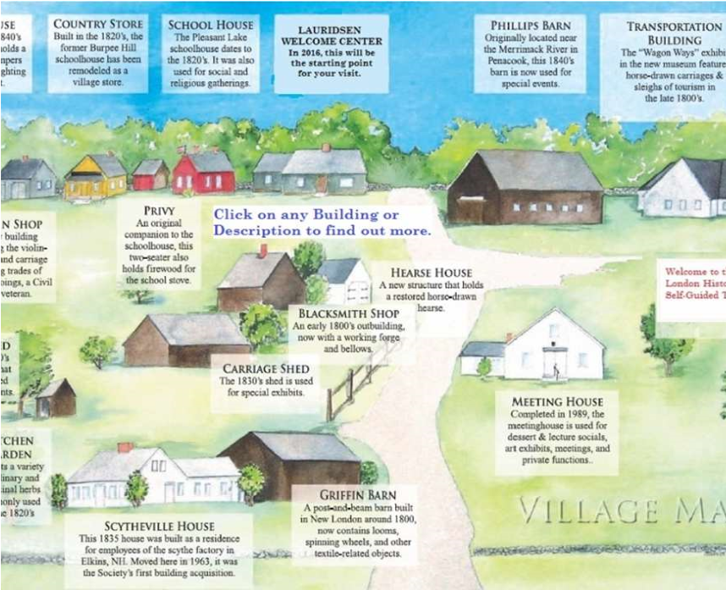

However, if you are using a smart-phone or a tablet in portrait mode, the interactive map may be too small to be useful. For those situations, the site also includes a “Building List” page which provides a list of all the buildings in the Village with each entry acting as a link to the corresponding building’s web page.

Most tablets and smart-phones will detect whether you are holding the device in landscape (wide) or portrait (tall) mode, automatically adjust the height and width of the display area and flip the display so it is always right-side-up. All of our web pages are set up to detect these changes and adjust the display accordingly. If the device is held in landscape mode, the display will usually be in two columns, with a video or picture of the building or item on the right and descriptive text on the left. If the device is held in portrait mode, the display will be in one column; with the picture above the text.

We have also installed signs with QR codes throughout the Village. If you see a sign with a QR code, this is your cue that we have a page on our site dedicated to that item. (To use the QR Code Reader app on your tablet or smart-phone, point the device’s camera at the code on the sign, and let the app “read” the QR code.) Because each QR code contains the web address for a specific page, you don’t need to use the Interactive Map or Building List pages to find that web page. However, not every exhibit in the tablet-assisted tour has a QR code sign posted. For this reason, it is often easier to use the internal web-site navigation to move from topic to topic. If you are viewing the page for one of the buildings, one of the vehicles in the Transportation Building, or viewing one of the YCN videos, there are **“Next >“** and **“< Previous”** links which will take you to other related pages.

GUEST BOOK PAGE

~~If you use the NLHS Tablet-Assisted Tour web~~ ~~site, we’d really like your feedback. First, we’d~~ ~~like to know how many people are taking~~ ~~advantage of this new option for touring our~~ ~~Historical Village. However, more than that,~~ ~~we’d like to know what you liked (or didn’t like)~~ ~~about our Village and the tablet-assisted tour.~~ ~~Any comments or suggestions that you would~~ ~~like to share with us would be appreciated.~~ ~~Just, follow the “Guest Book” link that is in the~~ ~~upper right corner of any page, and give us your~~ ~~feedback. Thanks in advance.~~

Because of problems created by “web trolls” that were generating bogus email messages, the “Guest Comments” function has been deactivated. We’d still like to hear from you, so please use the comment form on the NewLondonHistoricalSociety.org website

