Tablet-Assisted Tour Information for Lauridsen House Greeter

There are four tablet computers which are available for visitors to use during their visit to our village. Although they are of several different models, they all work the same. On the edge of the device there are two buttons, a short one and a long one. The short button is used to turn the device on and off. The long one controls the volume of the inbuilt speakers. If the device is powered on but the screen is off, tap the short button and a display similar to the one below should be shown. This is the starting page for the website. If a different page of the Interactive Tour website is displayed, there should be a “Home Page” entry in place of the “Village Map” entry shown below. Touch the screen where this text is displayed and you will be taken to the specified page. If the device has been turned off, press the short button to turn the device on.

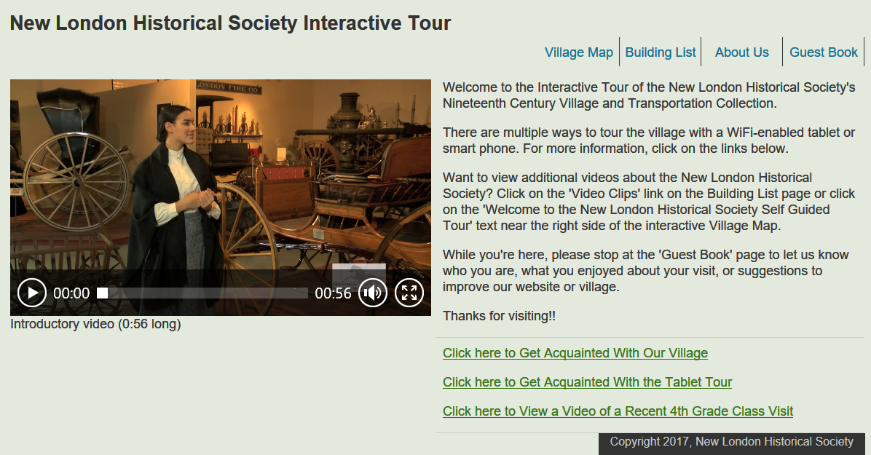

If the Interactive Tour website is not being displayed, it is likely that this application has not been started. If there are only a few icons displayed on the screen, one of them should have a big “**N**” in the middle of the icon. Tap the screen where this icon is shown and the home page for the Interactive Tour website should be displayed. Alternatively, there may be quite a few icons displayed, one for each application that is installed on the device. One of those icons should look like this and be labeled “**Chrome**”. Tap the screen where this icon is shown and the Interactive Tour home page will be shown.

There is also an icon for the **QR Reader** application, which uses the inbuilt camera to “read” the QR codes which are posted throughout the village. While some users may choose to navigate through the various web pages that way, most users will find it easier to use either the “Village Map” or the “Building List” options within the website to navigate from one page to another.

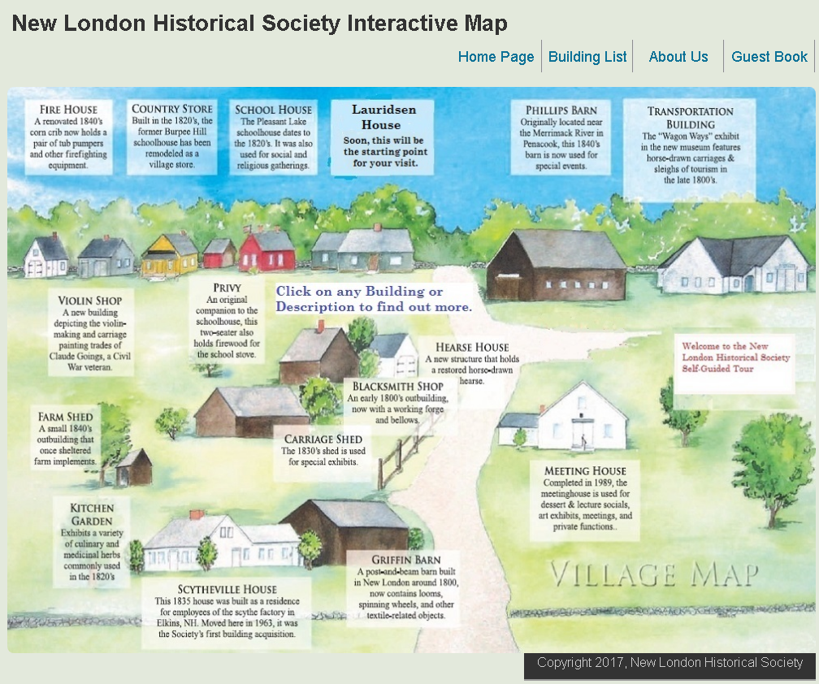The Village Map page works particularly well on a tablet when the device is in landscape mode. Touch a spot on the screen (either the image of a building or the associated text) and you will be taken directly to the associated web page.

To take advantage of the available screen space, the layout of each web page changes, depending on whether the device is held in landscape or portrait mode.

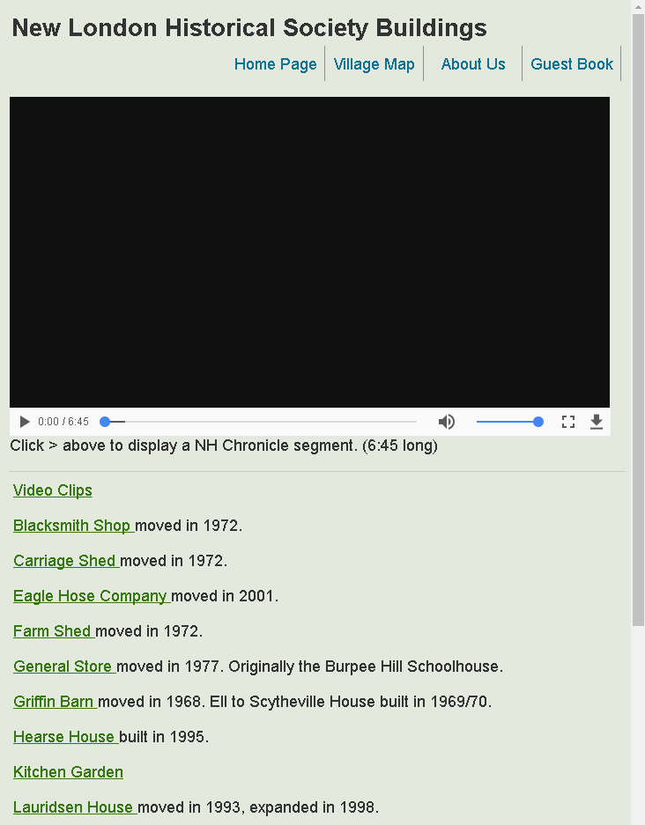The Building List page is more suited to the smaller screen of a smart phone or a tablet in portrait mode. It contains the same links as the Village Map page, but in a text format. This page also includes a video from the 2015 segment that WMUR did on us as part of their New Hampshire Chronicle series.

**A note on video files:** Most of the video clips that are imbedded in the web pages are set up to automatically display as soon as the file is loaded into memory. However, some wireless devices override this setting and each video has to be manually started. If a video doesn’t start automatically, click on the arrow in the lower left corner of the video area to start the video.

**Notes for** **Smart-Phone users:** Because the NLHS WiFi signal is stronger than any other WiFi signal while you are visiting the NLHS Historical Village, a smart-phone that has WiFi enabled will automatically try to connect to our network. And, since our network requires no password, this connection attempt should always be successful.

If you want to access our tablet-assisted tour web site from your smart-phone, this makes things extremely easy. However, if you normally leave WiFi disabled on your smart-phone and you want to use the device to view our tablet-assisted tour, you will need to remember to **enable WiFi** while you’re at the village.

If someone has their own smart-phone or tablet and would like to view the Tablet Tour on their device, refer them to the Tablet-Assisted Tour brochure or to the sign outside the General Store, which contains additional setup guidance. If a visitor isn’t familiar enough with the operation of their own device to follow these instructions, encourage them to use one of our devices, which are already set up.

**WiFi Hot Spots:** There are five locations where the WiFi signal is broadcast within the village. The wireless router is in the Meeting House, the primary WiFi access point is located in the Lauridsen House, and there are wireless repeaters in the Transportation Building, Carriage Shed, and Violin Shop.

**Laptop:** There is an older laptop that is also available for use in conjunction with the Tablet Assisted Tour. To use the laptop’s WiFi connection to access the site, click on the “Chrome” icon on the left side of the screen. You can then use this computer to demonstrate the website using a screen that is easier to see than the tablet. You could even connect an external monitor to the laptop, for viewing by larger audiences. (Switching between the inbuilt display and an external monitor is easy, but beyond the scope of the document.)

In addition, the laptop has a self-contained copy of the website, which can be used to demonstrate the features of the Tablet Assisted Tour in a location that does not have access to the Internet. To initiate this version, click on the “Self-Contained Demo” icon. However, it should be noted that the self-contained copy has not been updated since 2017, so the internet version of the website should be used if at all possible.

This device also works well as a mechanism to show any of the video clips that have been incorporated into the Tablet Assisted Tour, using either the intranet-based version or the self-contained version. You can even set up a video to run in “full screen” mode and to run as a loop, which allows that video to be viewed in an unattended mode without needing to be restarted.

Good candidates for unattended viewing? The “Fourth Grade Visit” video (on the home page), a merged version of the three “Get Acquainted” videos (on the About Us page), the Bud Lauridsen video that was created for Reflections 2015 (on the Lauridsen House page), and the NLHS feature segment that WMUR produced for NH Chronicle in 2015 (on the Building List page). There are also quite a few short clips from NH Chronicle and interviews from Kearsarge Chronicle that are available by clicking on “Video Clips” on the Building List page or by clicking on the “Welcome to the ... Self-Guided Tour” text on the Interactive Map page.

To view a video in full screen mode, move the mouse pointer so that it’s in the display area of the video. A set of small icons should appear at the bottom of the video. Click on the one that looks like this – [ ]. To return to normal viewing, press the ESC key in the upper left of the keyboard.

To set a video clip to run continuously, move the mouse pointer into the display area and Right Click on the video. A list of options will be displayed. Click on “Loop”. To stop looping, follow the same procedure.

**Note:** In the instructions above, “Click” means to use the left button on the mouse. “Right Click” means to use the right button.

**Debit/Credit Card Transactions**

The two Lenovo tablets can be used to process debit/credit card transactions through our PayPal account and a small magnetic stripe reader which plugs into the headphone jack on a tablet or laptop. (As of this point, we have not been successful in getting the PayPal Here application to recognize the reader when attached to either of the other tablets. For this reason, you may want to “hold back” one of the Lenovo tablets and not make it available for the tablet-assisted tour, if you anticipate needing to process credit/debit card transactions.)

On each of the tablets, there is a “**PayPal Here**” app. To use one of the Lenovo tablets for credit/debit card processing, plug the reader into the earphone jack and click on the **PayPal Here** icon. (Before plugging in the mag. stripe reader, you will have to take the tablet out of its protective case.) The user name is “**NLHSAdmissions**” and the password is “**nlhs03257**”. Once you’re logged in, there should be an icon in the lower left corner that sort of looks like a list of items. Click on this icon and it will bring up a list of items & prices. Touch an item in the list and it’s added to the shopping cart. If you select “Christmas Ornament” or “Building Replica”, you’re presented with a second screen which allows you to specify which item you are selling. To complete the sale, click on the “Charge” button at the top of the screen and scan the card.

The **PayPal Here** app has options to also accept debit/credit card transactions by keying in the 16 digit account number, creating an Invoice, or requesting payment from a PayPal account. Unless you are specifically told otherwise, DO NOT USE these options. Only process scanned credit/debit cards. However, you may encounter a situation where a visitor wants a receipt for a cash or check purchase. In this case, select the “Cash” or “Check” payment type, then enter the necessary recipient information and PayPal Here will issue an email or text message receipt.

Any transaction over $50.00 will require a signature. Hand the tablet to the customer and ask them to sign using their finger.

For each transaction, the customer has three options – emailed receipt, receipt via text message, and no receipt. If they want a receipt, enter their email address or cell phone number and the receipt is automatically sent.