What if the Tablet-Assisted Tour Doesn’t Work?  
(version 5.0)

While the equipment that supports the web site and wireless network is intended to run 24 hours a day, 7 days a week, things don’t always go as planned.

As of early August 2017, there was a major change in the makeup of the tablet-assisted tour. With the installation of Internet access in the village and the integration of the existing set of WiFi hot spots with our new Internet interface, it was possible to move the “website” from a computer in the Lauridsen House to a commercial web hosting service. Now, we can break things down into two categories – (1) Can the website be accessed, whether it be from the NLHS Historical Village or any other location with Internet access, and (2) Can a wireless device access the Internet, using the WiFi infrastructure in place at the NLHS Historical Village.

For the purposes of this document, we’re going to assume that the answer to the first question is “Yes”. If the tablet-assisted tour website is inaccessible, that’s a bigger problem than can be tackled in this document. On the other hand, we have contracted with a well-known web hosting service, so the likelihood of an outage on that end is fairly remote. Probably the greatest risk is that the web-hosting contract with GoDaddy.com expires due to nonpayment.

On the village infrastructure side, the first issue is that the WiFi network is not constructed of “industrial grade” components. While we can normally provide good coverage throughout the village, there may be circumstances where only part of the Village has WiFi coverage.

There are three major components to our village WiFi environment – (1) the wireless modem / wireless router in the Meeting House which connects the village to the outside world and also provides WiFi access to devices in the vicinity of this building, (2) the wireless access point in the Lauridsen House which connects to the modem / wireless router via buried cable and provides WiFi access to devices in the vicinity of this building, and (3) a group of WiFi repeaters in various locations throughout the village (Violin Shop, Carriage Shed, and Transportation Building) which pick up and rebroadcast the WiFi signal from either the router or the access point, providing WiFi access to devices in the vicinity of each repeater.

The router, access point, and repeaters provide a set of interconnected “hot spots” which allow a visitor to move throughout the Village at will. Since the router also provides connectivity to the Internet, a device that is wirelessly connected to any of our WiFi devices also has access to the entire Internet. (Our Internet connection is of relatively low bandpass. Consequently, users should be discouraged from using our network for “web surfing”.)

With the exception of the router, all the WiFi sources share the NLHS_Net basic network name, with each repeater using a variation on this network name for its identifier. NLHS_Net is the wireless access point in the Lauridsen House; NLHS_Net-2 is currently unused but may be added to the network to fill any identified “gaps” in coverage; NLHS_Net-3 is located in the back upper corner of the carriage side of the Violin Shop; NLHS_Net-4 is located on the partition in the Carriage House that separates the exhibit space from the storage space; and NLHS_Net-5 is located in the entry area of the Transportation Building. The router uses a slight variation of the network name – NLHSVillage.

Each WiFi source is set up with no sign-on security, so it should be quite easy to connect to one of these sources, although you may have to manually select the WiFi source via the Settings on your WiFi-enabled device, to get started.

If there is no Internet access in the village, the first place to check is the **Meeting House**. Using a tablet, smart phone, or laptop, see if the tour materials are accessible from near the Meeting House (inside or near the building, or from the Phillips Barn). If you can’t access the web site from here, then you won’t be able to access it from anywhere else.

**Solution** – The wireless router / DSL modem is located in the Meeting House kitchen, near the telephone and the back door. In addition to the power cord, there should be a short phone cable which connects the modem portion to the telephone circuit, and an Ethernet cable which connects to a jack near the floor which connects to the devices in the Lauridsen House. There should also be a cable connected in place of one of the in-built antennas, which connects to a high-power antenna that sits on top of the window sash. **If something is unplugged, plug it in.**

The second place to check is the **Lauridsen House**. Using a tablet, smart phone, or laptop, see if the tour materials are accessible from near the Lauridsen House (inside or near the building, from the Hearse House, or from the Schoolhouse). If you can’t access the web site from here, then you won’t be able to access it from anywhere else on this side of the driveway.

**Solution** – Now that the website is hosted elsewhere, the only component that is housed in the Lauridsen House is the WiFi access point. There should be one white cable plugged into the access point and one of the five numbers (1, 2, 3, 4, and 5) on the front of the access point should be illuminated. The other end of the cable should be plugged into a wall jack which connects to the router in the Meeting House kitchen. There should also be a cable connected in place of one of the in-built antennas, which connects to a high-power antenna that sits on top of the window sash. **If something is unplugged, plug it in.**

If there is WiFi connectivity around the Lauridsen House, it is likely that there is also WiFi connectivity for **at least some of the rest of the village**. As previously mentioned, there are three additional WiFi sources which may be affected. Depending on the amount of outage, it may be appropriate to just make a note of which areas are without coverage and leave the problem resolution for later.

**Check the following locations:**

1. Check for WiFi access in the exhibit area of the **Transportation Building**.

**Solution** – There is a WiFi repeater (small white plastic box with two antennae) plugged into an electric outlet in the entry area of the Transportation Building, near the door to the workshop. **If the repeater is unplugged, plug it in.** (This WiFi repeater couples with the router in the Meeting House, rather than the WiFi access point in the Lauridsen House and, as a result, may provide WiFi access even if the WiFi components on the south side of the driveway are out of service.)

1. Check for WiFi access when standing between the **Eagle Hose Company** and the Violin Shop.

**Solution** – There is a WiFi repeater in the Violin Shop, up against the rafters in the back corner of the building closest to the General Store. You should be able to see a single red LED, indicating that the device is on and connected to the router. **If the repeater is unplugged, plug it in.**

1. Check for WiFi access when standing between the **Carriage House** and **Griffin Barn**.

**Solution** – There is a WiFi repeater along the top of the partition wall of the Carriage House, close to the driveway and attached to a long extension cord. (Since all the electrical outlets in the exhibit portion of the Carriage House are on a wall switch, this repeater gets its power from an outlet in the other end of the building. However, because the repeater has to be somewhat close to the WiFi signal source in the Lauridsen House, it is located here.) **If the repeater is unplugged,** **plug it in. If the light on the repeater isn’t on, you may have to open the storage end of the building to check the other end of the extension cord.**

**🡪 WiFi Hot Spots 🡨**

We have five spots in the village where the WiFi signal is broadcast. Each of these “hot spots” has a similar, but not identical, name. They are each configured with no password, so it should be simple to connect to each of these locations. However, depending on the configuration of your tablet or smart you may need to go into “Settings” and manually “Connect” to your closest hot spot.

The hot spots are as follows:

NLHSVillage Meeting House (wireless router)

NLHS_Net Lauridsen House (wireless access point)

NLHS_Net-3 Violin Shop

NLHS_Net-4 Carriage House

NLHS_Net-5 Transportation Building

It is possible that the individual devices may get swapped from time to time. Additionally, NLHS_Net-2 is currently unassigned and may be added to the configuration. However, the device names for the hot spots in the Violin Shop, Carriage House, and Transportation Building should always be “NLHS_Net-“, followed by a number. (Since NLHS_Net-5 is set up to replicate the WiFi signal from NLHSVillage, not NLHS_Net, this repeater should not be relocated to a spot that isn’t within WiFi range of the Meeting House.)

**Technical Stuff**

What follows is a summary of the hardware and software configuration that makes up the New London Historical Society’s internet/intranet and tablet tour environment.

**Server hardware:** With the addition of a commercial website hosting service, there is no longer a need for a dedicated web server. Consequently, the workstation/server has been removed from Lauridsen House and is now unused, on the floor of the back office at 73 County Road.

**Server software**: The website is now hosted on a Unix server managed by GoDaddy.com. This environment supports all the functionality previously available with our dedicated web server, plus a whole lot more functionality that we aren’t currently using. This provides support for .html and .css files which make up the basis of the website. It also provides support for server-based .php files which handle the data capture portion of the “Guest Book” page. (The Guest Book page was disabled in early 2020, due to a large number of “junk” entries which were generated by automated “bots” that troll the internet. It has been reactivated after an “I Am Not A Robot” check was implemented, which should prevent these bogus entries.)

**WiFi router:** When a DSL Internet connection was established in the Meeting House, a new modem / wireless router was provided by TDS, our telecommunications vendor. The WiFi network name for the router was changed to “NLHSVillage” and the network password was disabled, allowing any wireless device to connect.

**WiFi access point:** When the wireless router was installed in the Meeting House, the previous wireless router, in the Lauridsen House, was taken out of service and replaced by a wireless access point. This access point provides a hard-wired connection point for the server and broadcasts the WiFi signal to the WiFi repeaters located throughout the village. This device, along with the router and all the WiFi repeaters, have been configured with no password required, making the network totally open to anyone in the immediate vicinity.

**WiFi Range Extenders:** Because there is no wired Ethernet connection to the Internet except in the Meeting House and Lauridsen Building, it is necessary to use another technology to extend the WiFi environment beyond the range of these two devices. A range extender receives the WiFi signal from a WiFi router or access point and rebroadcasts it. Because these devices must be placed within range of the router or access point signal and they double the WiFi radio traffic, they were a somewhat less desirable option to other methods to extend WiFi coverage to the entire Village. However, they have proven to be fairly reliable and now form the backbone of the NLHS_Net WiFi intranet.

**WiFi devices:** As a starting point, three Android tablets were acquired in 2016 and a fourth tablet was acquired in 2017. Two are Lenovo tablets with 8 inch screens, another is a DigiLand tablet with a 7 inch screen, and the last is an Insignia tablet with an 8 inch screen. (The first Lenovo tablet was purchased because Lenovo is a recognized brand. While this tablet performs adequately, the screen is not as touch-sensitive as had been hoped. The DigiLand tablet was purchased to try a slightly smaller device, and from a different vendor. This device seems to perform well, although it is suspected that an 8 inch screen may be the more desirable size for many users. Since DigiLand doesn’t sell an 8 inch Android tablet, the Insignia tablet was selected as a third device.) With the addition of “PayPal Here” debit/credit card processing, a second Lenovo tablet was acquired, as the DigiLand and Insignia tablets appear to be incapable of supporting the card-swipe reader.

While Android devices tend to be less expensive than either iPad or Windows tablets, any WiFi-capable device can be used. There are two “apps” which have been added to each tablet. First, the QR Code Reader app by Scan, Inc. has been installed. While there are multiple apps which provide the necessary capability, the Scan, Inc. version seems to be one of the most effective and easiest to use. Second, the tablet needs to be set up to seamlessly display video in .mp4 format. VLC for Android by Videolabs accomplishes this, although there are other apps with similar capabilities. Since the web site uses standard HTML constructs, any current web viewer can be used. And, since all Android devices come with the Chrome web browser pre-installed, that is the assumed operating environment for the site.

A Dell laptop, running Windows NT, was acquired at no cost. This device is available to the Village Host and can be used as a terminal to provide access to the tablet tour materials on a larger screen than is available with the tablets. This device may connect to the web host via either WiFi or traditional (hard-wired) Ethernet, as needed. A local version of the original non-Internet website has been loaded onto this workstation, for use in off-site and demonstration roles. However, this local version of the website has not been updated since 2017, so it should not be used.

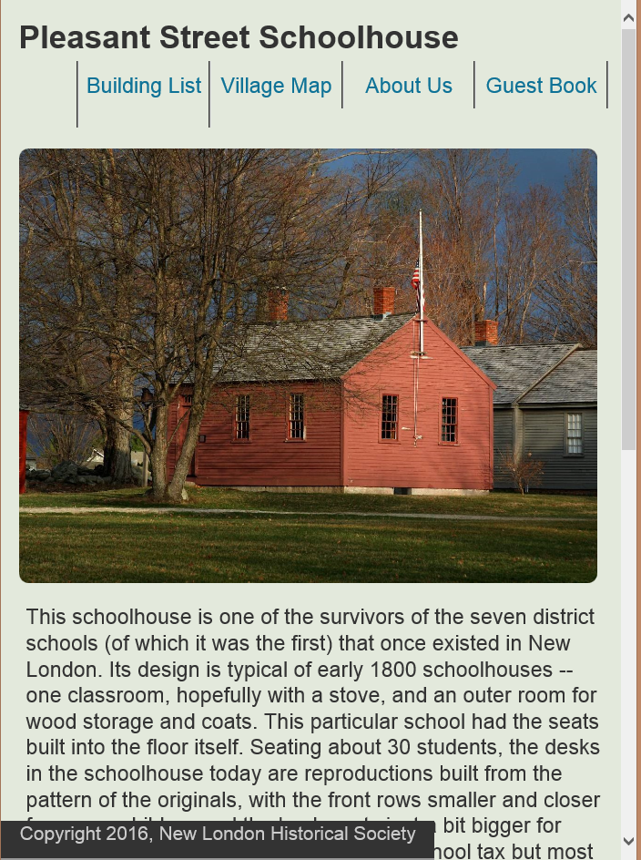**Website software:** The bulk of the software specific to the NLHS tablet tour consists of a series of .html (HyperText Markup Language) files, one per web page. (Technically, the site uses HTML5 constructs. This is the current “standard”.) The basic website layout is defined in a single .css (Cascading Style Sheet) file, with a second .css file that manages style issues specific to the “Guest Book” page which supports user feedback. The Guest Book page also uses a .js (JavaScript) file which does some validation of the user input before it is sent back to the server, and a .php file which defines the server-based processing of the user input. The guest book data is reformatted and sent in an email to [info@NewLondonHistoricalSociety.org](mailto:info@NewLondonHistoricalSociety.org). (The Guest Book page was deactivated in early 2020, due to a large number of bogus postings, but was reactivated after addition of an “I’m Not a Robot” test.)

The remaining files that make up the site are images (in .jpg format) and video files (in .mp4 format). In 2021, the text of many of the pages was processed through a text-to-voice application and the generated audio files (in .mp3 format) were added to these pages. The goal was that either a video file or an audio file would automatically be presented each time a new web page was loaded.

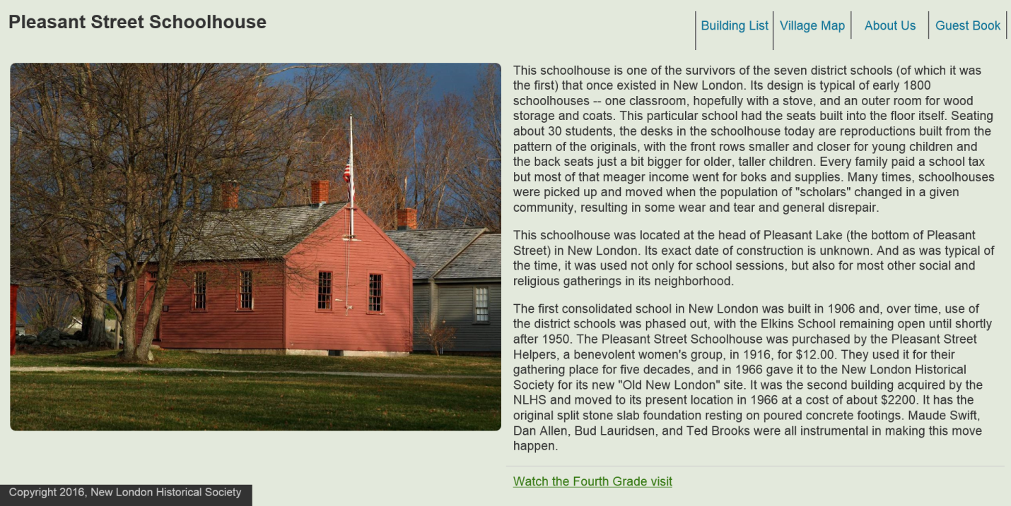

**Website Layout:** The primary .css file defines seven separate areas on the page and is designed to support both landscape and portrait display. The “header” section defines the header for the page. The “banner” section defines the link area, either displayed on the same line as the header or on the next line, depending on display width. The “left-panel” section defines the first portion of the web content, and normally contains a .jpg image of the exhibit item, either displayed near the top of the page or on the left side, depending on display width. The “right-panel” section, on most pages, defines the text that describes the exhibit item, and either follows the “left-panel” section or is displayed on the right side of the page. The “third-panel” section can be used to display information immediately below the ”left-panel” section in landscape mode or immediately below the “right-panel” information in portrait mode. The “fourth-panel” section defines an area used to link to additional videos, and is displayed immediately below the “right-panel” section. Finally, the “footer” section defines the area used for the copyright statement, and is displayed after all other items on the page. An eighth “fullpage” area is also defined in the .css file and is intended to replace the “left-panel”, “right-panel”, “third-panel”, and “fourth-panel” sections on those pages that only display a single item, such as a video.

(The contents of the “right-panel” are sometimes defined before the “left-panel” within the HTML. In this situation, the right-panel contains the .jpg image and the left-panel contains descriptive text. This is done when the descriptive text is longer than the height of the image and allows the “navigation” portion to immediately follow the image. By defining the right-panel first, the image will be displayed above the descriptive text when the display is in portrait mode, but will be displayed to the right of the descriptive text when in landscape mode.)

**HTML Editor:** While there are a wide variety of editors available, the free version of the CoffeeCup HTML Editor is more than adequate to the task, and has been installed on the laptop. This editor can also be used to maintain the .css, .js, and .php files. In addition, the free version of the CoffeeCup FTP program is more than adequate to copy website files to and from the GoDaddy server.

**Web Host:** The current [www.NewLondonHistoricalSociety.org](http://www.NewLondonHistoricalSociety.org) website, hosted on Weebly, does not support HTML-based web pages. Consequently, a second domain name, [www.NLHSVillage.org](http://www.NLHSVillage.org), has been licensed and this new site is now hosted on a GoDaddy web server. It is possible that, by integrating the content of the two websites, users may be presented with a browsing experience that takes advantage of the capabilities of both environments while appearing to be somewhat seamless.

**Home Page:** The home page for most websites is the “index.html” file at the root level of the web domain (“ [www.NLHSVillage.org/index.html](http://www.NLHSVillage.org/index.html)”, in our case). However, this website was initially set up to provide an entry point for more than just the Tablet Tour. As a result, the home page for the Tablet Tour was originally set up as “[www.NLHSVillage.org/Tablet.html](http://www.NLHSVillage.org/Tablet.html)”. (Note the capitalization. Because the website is hosted on a Unix server, “Tablet.html” and “tablet.html” are not synonymous.) In 2020, this structure was changed. Now, the “index.html” and “Tablet.html” files are identical, with the “Tablet.html” page only being retained for compatibility with the previous implementation. Consequently, you can use either url to access the website. The original index.html page was renamed as “oldindex.html”, is accessible from the “About Us” page, and contains links to experimental versions of some pages.